SETUP MMG DEMOS
The MMG demos run on one laptop and can connect to multiple iPads via WiFi. The UoA-WiFi or eduroam don’t allow us to that, therefore we create an own network for the iPads to connect to. There are two options:
- Preferred option: Use a router to generate a local network. The tablets then connect to the router WiFi.
- Connect the laptop to the available network (e.g., UoA-WiFi), then create a hotspot from the laptop and connect the iPads to the hotspot.
Why this is not recommended: The hotspot is not as stable as the router. It may be sufficient, if we are in a small space, just connecting 2-3 iPads.
You can connect to the UoA-WiFi using your UoA credentials. We recommend deleting your credentials from the WiFi settings once you are done. On the laptop, go to Settings > WiFi > Manage known networks and click on “Forget”.
You need the following items:
- MMG demo laptop – stored in Mocap room on L8
- iPads – pick up from IT (L1) after booking them through the ABI calendar
- Router (Linksys) – pick up from IT (L1) after emailing Callum (callum.mccarthy@auckland.ac.nz) that you want to use the router.
How to book the iPads:
- Log in to the ABI (Room) booking system: https://rooms.bioeng.auckland.ac.nz/
- On the dashboard page, go to “Resource Availability”
- Find the iPads, e.g., “iPad One (UOA411734)”
- Click on “Reserve” and fill out when you need it
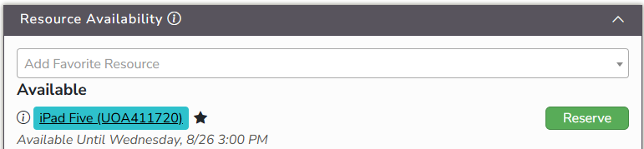

Password for iPads:
The password for the ABI iPads is abihouse
How to start the demos:
- Turn on the MMG demo laptop – select the user “Administrator”, no password required.
 | Option A: Use router | Option B: Use hotspot of laptop
2. | Unpack the router, plug it in, and turn it on. Plug the LAN cable into “Ethernet 1”. | On the laptop, open the Settings > Network & internet > Mobile hotspot. Turn on the hotspot.
3. | Connect the router with the laptop using the LAN cable (and the USB-to-LAN adapter). On the laptop, switch WiFi off. | For each iPad, scan the QR code from the laptop hotspot settings to connect.
4. | On each iPad, go to the WiFi settings and connect with “Linksys”. If required, the password is on the back of the router. | Double-check that the iPad is connected to the hotspot “MMG-demo” in the WiFi settings.
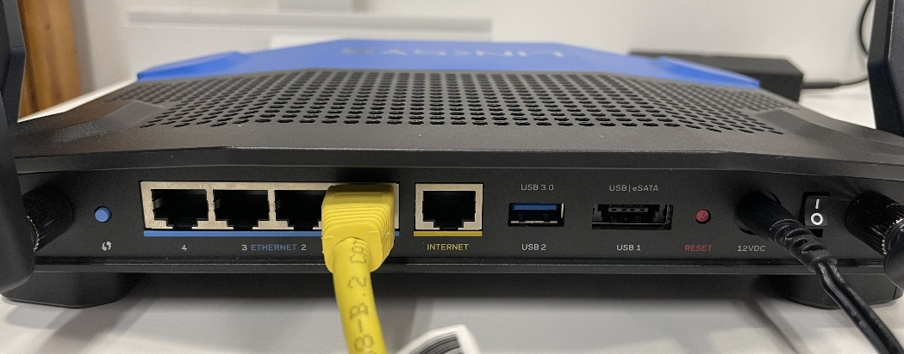
- On the laptop, open the Anaconda Prompt (shortcut on the desktop) and run:
conda activate demo
- Start the server dashboard by running:
python Desktop\mmg_demo\DemoServer\dashboard.py
A window with the dashboard will open.
- Click “Start” to start the server.
- Copy the URL shown and open it in the Internet Browser of the laptop – this is just a sanity check that the server is running.
- Only if this iPad has not been set up before: On the dashboard, go to “ACCESS” and scan the QR Code “Trust a new tablet”. Follow the instructions to download the certificate.
- On each iPad, open Settings > General > About and enable the Trust certificate “Administrator”
- For each iPad, scan the QR code to connect to the server. If you receive a message “This is not a secure connection”, click “view more” and accept.

